Lab # : 1; Lab Name :Creating Amazon EC2 Server using UCB AMI ; Subject Name : Information Storage and Retrieval; Week #: 1; Lab Duration : 20 to 30 mins

# Intro

In this lab, we will get to know the environment that we will use for the labs and exercises in this course. We will learn about the followings:

* Amazon EC2 Environment and your Account
* What is an AMI?
* How to find an AMI and launch a server
* How to chose a server
* How to check already installed software on the server

Let’s go!

### Step-1. Amazon EC2 Environment and your account

By now, you should have received an email about your Amazon EC2 Account information. Please find the amount of credit you got as well, so that you can plan to use it over this course for doing your labs and exercises. Just note that, Amazon EC2 credits are used when your server is running. You can always keep an eye on the balance of your account in the Amazon EC2 Console.

For getting familiar with Amazon EC2, you could refer to the following links.

a. <http://en.wikipedia.org/wiki/Amazon_Elastic_Compute_Cloud>

b. <http://en.wikipedia.org/wiki/Amazon_Web_Services>

Also, to login to your account, go to the following link, <http://aws.amazon.com>. You will reach to the following screen. Click on the “My Account” link to login with the credential provided. 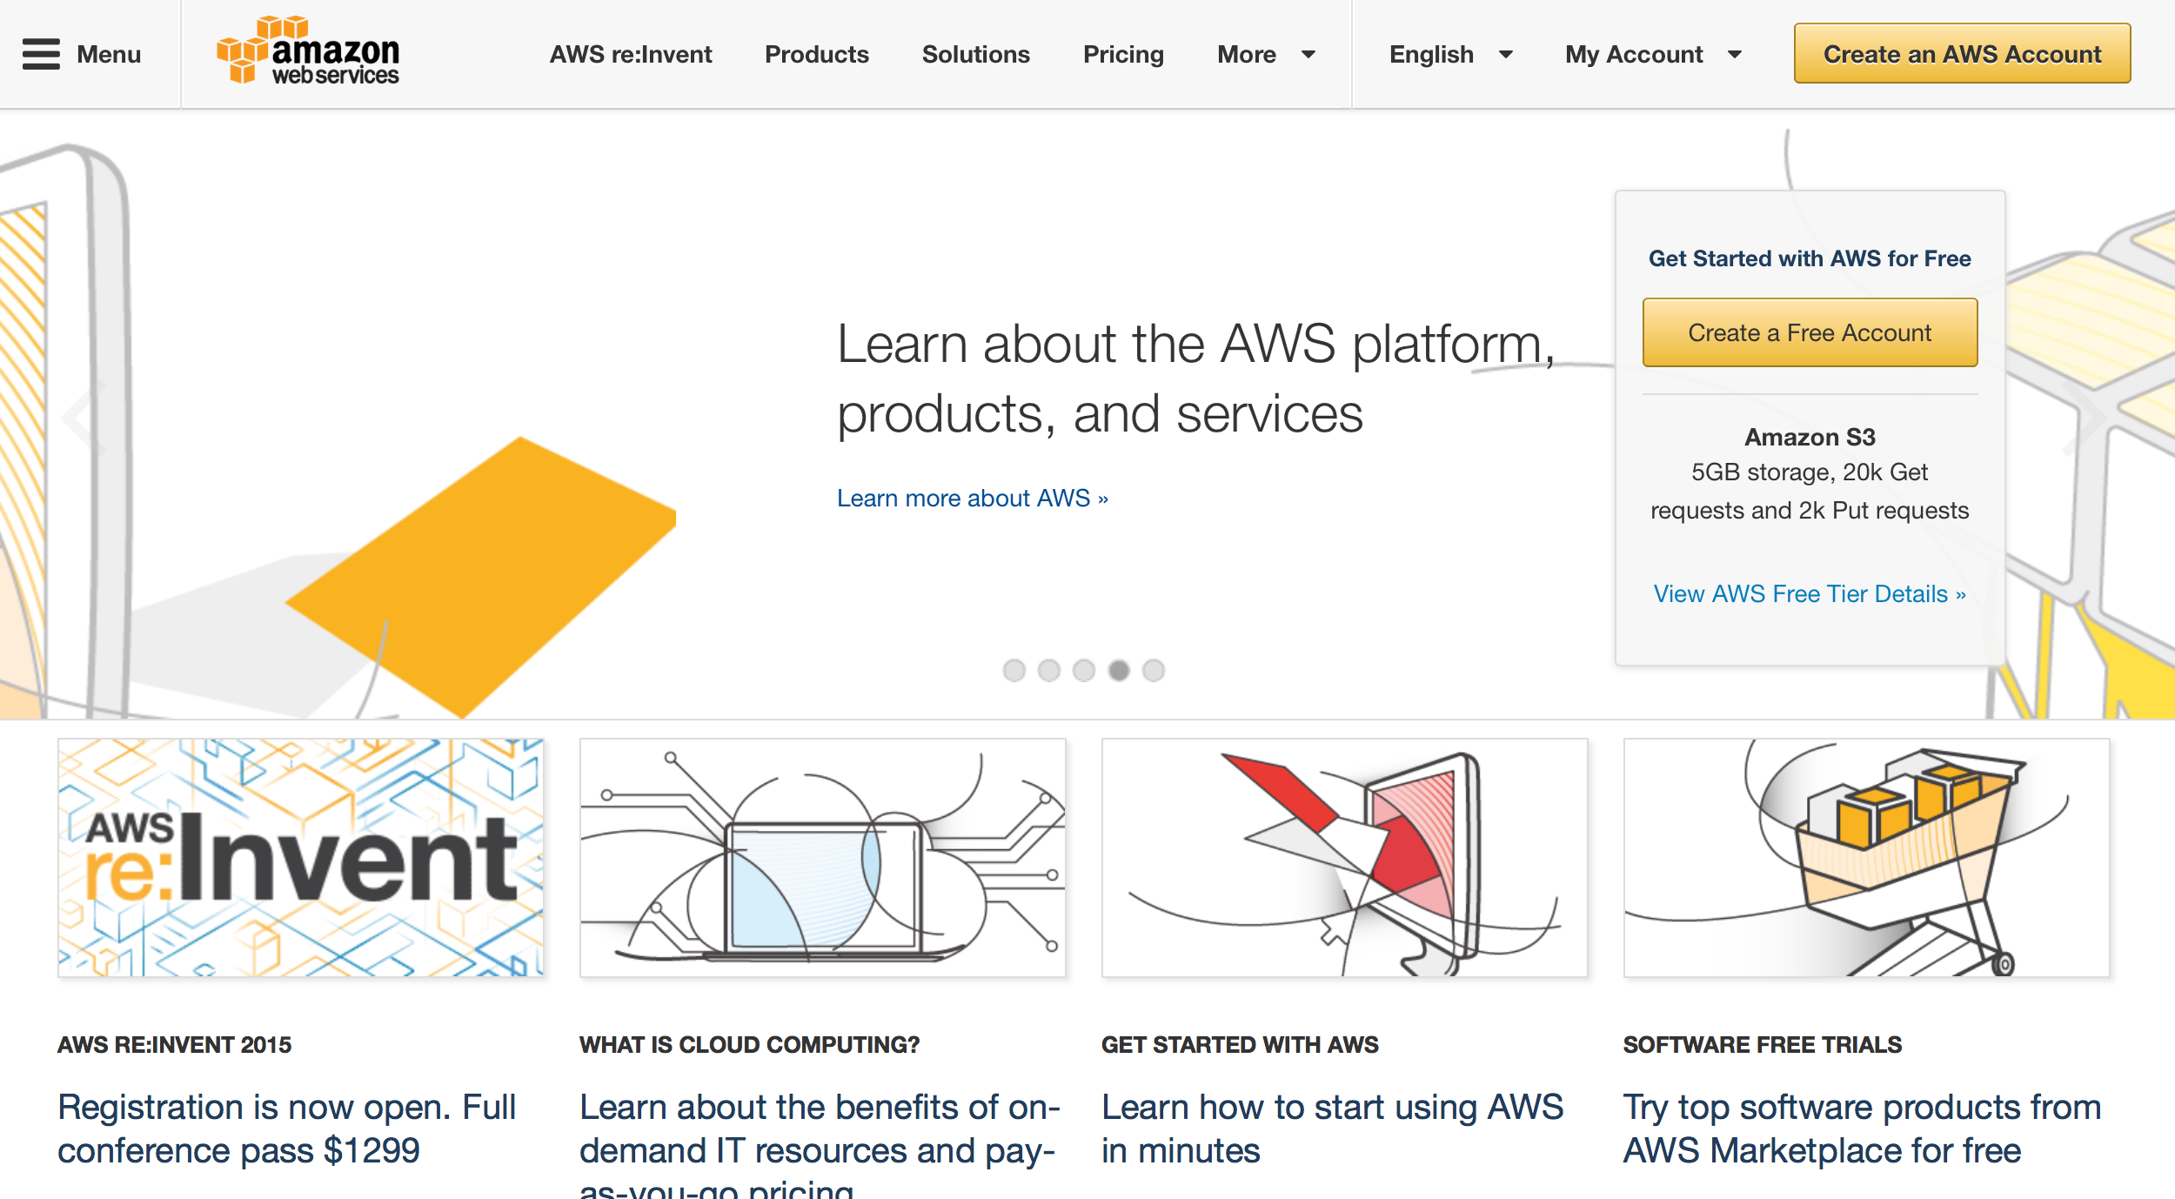

Verify your account balance and if you have any question or concern, please contact.

Amazon provides various types of VMs/Servers for your particular need. You can get familiar with types of servers, Amazon EC2 provides, in the following link, [http://aws.amazon.com/ec2/instance-types/ .](http://aws.amazon.com/ec2/instance-types/)

Here are a few examples of Amazon EC2 M3 Servers.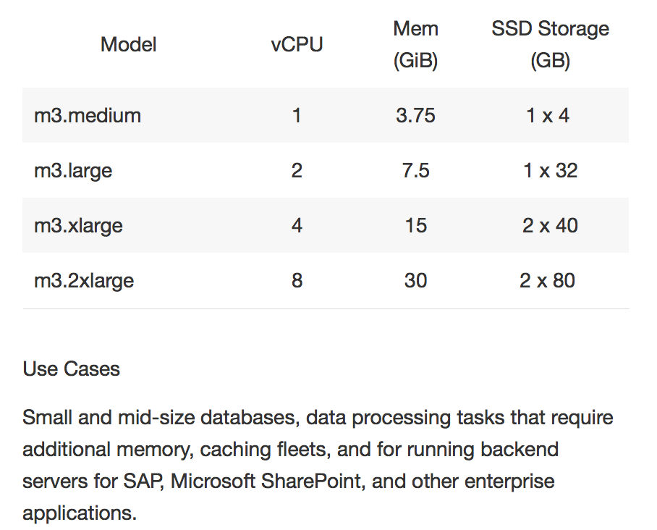

### Step-2.What is an AMI?

An Amazon Machine Image (AMI) is a static state of a server. It doesn’t use CPU or I/O. You can launch as many servers you want using an AMI. In EC2, the launched servers would be mainly VMs in the cloud.

The following link has a great detail about AMIs:

<http://docs.aws.amazon.com/AWSEC2/latest/UserGuide/AMIs.html>

Once an AMI is created, it needs to be registered. If you want others to access your AMI, you must grant permission to that user or make the AMI public. A public AMI is accessible to anyone to use and launch a server based on that AMI.

### Step-3. How to find an AMI and Launch a server

You can use the following steps to find an AMI:

Open Amazon EC2 Console using the following link, <http://aws.amazon.com/ec2/> and click on “My Account” drop down menu and click on AWS Management Console. Log in with your credential

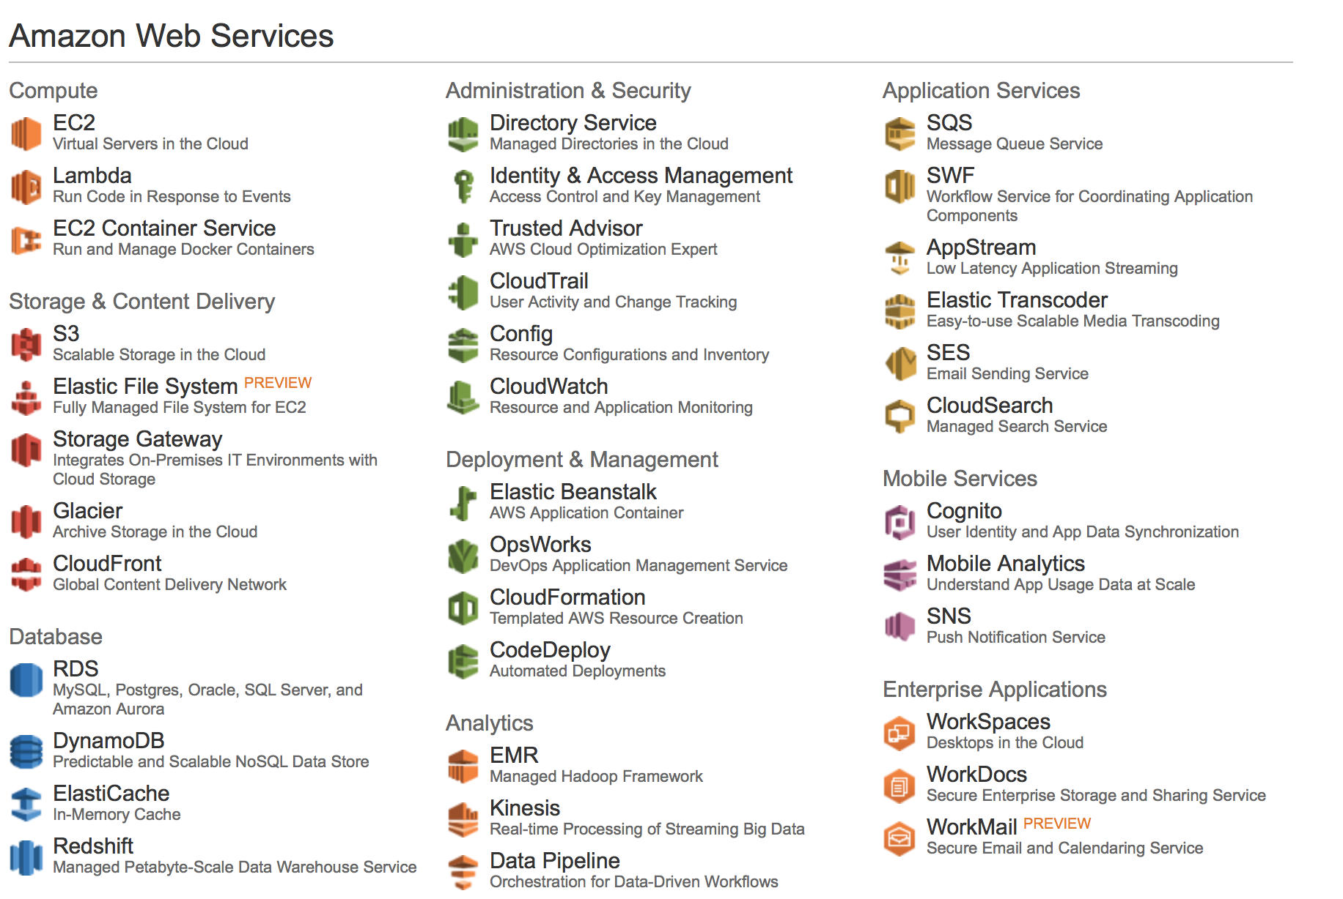

This is a great link for launching an Instance as well : <http://docs.aws.amazon.com/AWSEC2/latest/UserGuide/launching-instance.html>

Once you have logged in, click on Instance in order to launch your instance. In this case, you will be using the AMI provided by UCB. You need to search for the AMI and select the UCB AMI in the following screen:

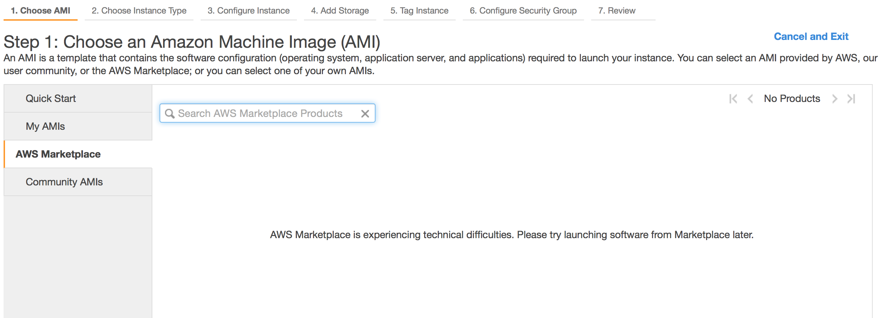

Next, you will chose the Instance Type. You can chose here a m3.medium. Please check the configuration for this.

Once you have started creating the server using the UCB AMI, you can check progress of your server forming.

The UCB AMI that you will be using for this subject is : UCB-205-Exer-Labs-ver-1.0

### Step-4. How to chose a type of server

There are various types of servers available on Aamazon EC2 environment. However, you will chose one in which you could run Hadoop and several softwares which are necessary for your labs and exercises.

Please refer to the above link for the types of servers available.

**Step-5. How to find which software is already installed on the server**

Once you have created you server/instance using the UCB AMI, you should find the following software with the respective versions.

* Python 2.7.3
* HDFS
* Mysql
* Hive
* Apache Spark
* Apache Sqoop
* Mysql Loader
* Cloudera Express 5.4.1

You can check if these are installed and the location of the software using unix commands like “which”. i.e. which hadoop will give you the location of hadoop binaries.

Pending:

1. Exact AMI Name
2. Cleanup Steps to be more specific
3. Add few more screen shots if needed
4. Align with UCB email